https://www.linncountytrails.org/, accessed February 17, 2026

April 2025 Trail News
Apr 30, 2025
Updated: Jun 9, 2025
CEMAR – Connecting two cities!
Interurban Trail updates
ConnectCR -starting soon!
Indian Creek/CEMAR/GWT segment in 2025!
Singletrack Mountain Bike trail update
Have we got a LOT of events for the Spring, Summer and Fall

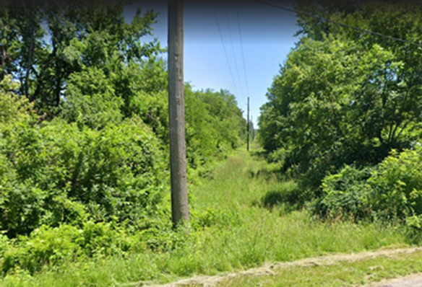
Interurban Trail

The SE Cedar Rapids portion of the Interurban Trail will be built in two Phases. The first phase is from the Forest Dr SE and Cottage Grove SE intersection to East Post Rd SE. The second phase is from East Post Rd SE to Mt Vernon Rd SE where it meets up with the Sac & Fox Trail. Design work on both Phases is expected to begin in 2025. The City will select a Consultant for the design this month. With your help, LCTA is contributing $100,000 towards the design of Phase II.

