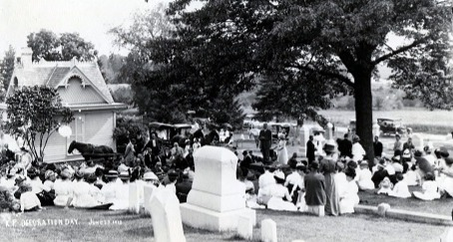

Mount Vernon Cemetery Commission
Meeting Agenda
Tuesday, June 10, 2025

The Mount Vernon Cemetery Commission will meet in open session
Tuesday, June 10, 2025 at 6:30 P.M. at City Hall Conference Room.

Call to order

Introduction of guests

Approval of minutes from May 13, 2025

New Business
- Maintenance of cemetery records and documents
- Restoration and preservation of cemetery monuments
- Maintenance of cemetery grounds
- Discussion of burial services offered in Iowa
- Promoting and publicizing the cemetery

Old Business

Adjournment

Next meeting Tuesday, July 8, 2025

City Hall Mount Vernon, Iowa 52314

